**To sail at the lowest place in the world**

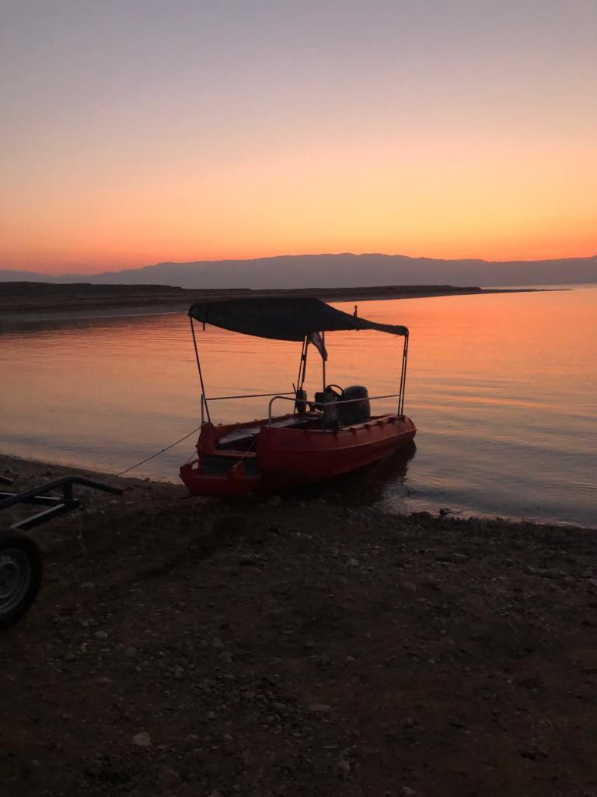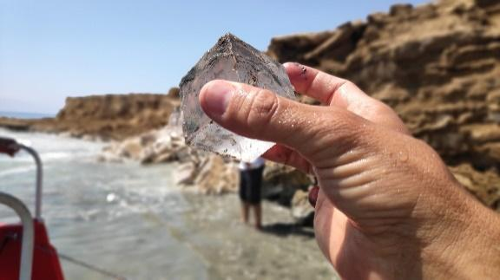

**Not every day are we given the opportunity to discover the Dead Sea from a unique angle.**

**During the activity, we will be exposed to unique salt landscapes that can be seen only from the Dead Sea. Among them are perfect salt diamonds, salt pearls, sea salt flakes, salt stalactites, and salt caves in various configurations.**

**The experience is possible by boats (up to 24 people).**

**The operators hold all the licenses and insurance**

**Sailing:**

* **Up to 10 pax - 2.100 NIS. (Same price also if there are less people)**
* **11 pax - 2.295 NIS. (Same price also if there are less people)**
* **12 pax - 2,490 NIS. (Same price also if there are less people)**
* **20 pax (two boats) – 4.050 NIS. (Same price also if there are less people)**
* **24 pax (two boats) – 4,830 NIS (Same price also if there are less people)**

**Cost for 3 hours tour:**

* **10 pax – 3.100 nis (Same price also if there are less people)**
* **12 pax – 3,690 nis (Same price also if there are less people)**
* **20 pax – 6.050 nis (Same price also if there are less people)**
* **24 pax – 7,230 nis (Same price also if there are less people)**

**General Comments:**

**Price does not include:**

* **Transportation from the road to the parking lot: The entrance is on a packed hard limestone road, about 1 km drive to the vehicle parking). Please check in advance.**
* **Individual water bottles (for ecological reasons).**
* **Anything else not specified in the proposal.**
* **Please note that there are no toilets on the beach (toilet services are at the gas stations or at the lido junction !!**

**Additions:**

**We recommend bringing:**

**Sunglasses, suntan lotion and a wide-brimmed hat.**

**Shoes suitable for water.**

**A bathing suit and a shirt (or a garment that can get wet).**

**A change of clothes and a towel.**

**Personal drinking water.**

**Conditions of payment:**

**Prices include VAT**

**Cash / Check cash on the day of the activity / bank transfer the day before the activity. the transfer only from bank in Israel.**

**Payment is in NIS only.**

**Payment for a delay of more than 20 minutes - 500 NIS + VAT.**

**In case of a delay of more than 30 minutes, the trip may be cancelled.**

**In case of cancellation within 24 hours - full charge.**

**In case of cancellation within 48 hours - 75% of the cost of the activity.**

**Payment according to the number of people reserved.**

**In the event of extreme weather that does not allow the activity to take place, cancellation may be done by the supplier only**

**and at his professional discretion only.**

**Order form**

**No handwriting – Please type!**

| **Your company name / Client's Name** |  |
| --- | --- |
| **Company ID #/ private ID #** |  |
| **e-mail address (for the receipt)** |  |
| **Phone #** |  |
| **Payment method** | **Cash/check / Bank transfer** |
| **Private Address** |  |
| **Contact person on the activity day** |  |
| **Cell phone #** |  |
| **Date and time** |  |
| **PAX** |  |
| **Price (as shown on the price list obove)** |  |

**There may be cancellations due to weather conditions (weather cannot always be predicted in advance)**

Terms of Payment:

**The payment will be made in cash, or by bank transfer on the day of the activity itself .and only from bank in Israel.**

**If the payment is made by bank transfer, it must be executed one day prior to the activity and send a document.**

**In addition, this form of commitment must be signed.**

| **account details:** |
| --- |
| **לפקודת נופי מלח / יעקב בן זקן** | |
| **דיסקונט 11** | |
| **סניף רמת אשכול 109** | |
| **מספר חשבון 148685309** | |

|  | **I hereby declare that I may make a commitment in the name** |
| --- | --- |
|  | **ID and signature** |
|  | **Role** |
|  | **Date** |
|  | **Stamp** |

**Conditions of payment:**

**Prices include VAT**

**Cash / Check cash on the day of the activity / bank transfer the day before the activity.**

**Payment is in NIS only (Shekel).**

**Payment for a delay of more than 30 minutes - 500 NIS + VAT.**

**In case of a delay of more than 30 minutes, the trip may be cancelled.**

**In case of cancellation within 24 hours - full charge.**

**In case of cancellation within 48 hours - 75% of the cost of the activity.**

**Payment according to the number of people reserved.**

**In the event of extreme weather that does not allow the activity to take place, cancellation may be done by the supplier only and at his professional discretion only.**

**Arrival and meeting place:**

**Arrive at** [**Kibbutz Mitzpe Shalem junction**](https://www.google.com/maps?q=31.5590441,35.4032742&z=17&hl=he) **on Route 90, and from there continue accompanied by us to the parking place. About A kilometers on a gravel road**



